Where to go next? Predicting habitat suitability of an expanding mesocarnivore – the golden jackal (Canis aureus) in Europe

N. Ranc^{1,2}, F. Cagnacci², O.C. Banea³, T. Berce⁴, D. Ćirović⁵, S. Csànyi⁶, G. Giannatos^{7,8}, M. Heltai⁶, J. Lanszki⁹, L. Lapini¹⁰, L. Maiorano¹¹, D. Malešević¹², D. Migli¹³, J. Mladenovič¹⁴, I.A. Pankov¹⁵, A. Penezić⁵, M. Šálek^{16,17}, I. Selanec¹⁸, S. Stoyanov¹⁹, L. Szabó⁶, I. Trbojević¹², and M. Krofel¹⁴

AUTHOR AFFILIATION

(1) Harvard University - Organismic and Evolutionary Biology Department, 26 Oxford Street, MA 02138 Cambridge, United States
(2) Fondazione Edmund Mach - Centro Ricerca ed Innovazione, Via Mach 1, 38010 San Michele all'Adige (TN), Italy
(3) Crispus NGO - Ecology Department, Str Papiu Ilarian Nr 14, Sibiu, Romania
(4) Slovenia Forest Service, Večna pot 2, SI–1000 Ljubljana, Slovenia
(5) University of Belgrade - Faculty of Biology, Studentski trg 16, 11000 Belgrade, Serbia
(6) Szent Istvan University - Institute for Wildlife Conservation, István utca 2, 1078 Budapest, Hungary
(7) University of Athens - Department of Biology, Section of Zoology and Marine Biology, GR-15784 Panepistimioupolis, Athens, Greece
(8) Ecostudies PC - Environmental studies, Athens, Greece
(9) University of Kaposvar - Department of Nature Conservation, Guba Sándor u. 40, H-7400 Kaposvár, Hungary
(10) Friulian Natural History Museum - Zoology Section, Via Marangoni 39, 33100 Udine, Italy
(11) La Sapienza University of Rome - Dipartimento di Biologia e Biotecnologie "Charles Darwin", viale dell'Università 32, 00185 Roma, Italy
(12) University of Banja Luka- Faculty of Science, Mladena Stojanovića 2, 51000 Banja Luka, Bosnia and Herzegovina
(13) Aristotle University of Thessaloniki, School of Biology - Department of Zoology, GR-54124, Greece
(14) University of Ljubljana - Biotechnical Faculty, Dept. for forestry, Večna pot 83, SI-1001 Ljubljana, Slovenia
(15) National Museum of Natural History (NMNHS), Bulgarian Academy of Science, Bulevard Tsar Osvoboditel 1, Sofia, Bulgaria
(16) Academy of Sciences of the Czech Republic - Institute of Vertebrate Biology, Květná 8, 603 65 Brno, Czech Republic
(17) University of South Bohemia - Faculty of Science, Department of Zoology, Branišovská 31, 370 05 České Budějovice, Czech Republic
(18) Association BIOM, Preradoviceva 34, 10 000 Zagreb, Croatia
(19) University of Forestry - Wildlife Management Dept., 10 Kl. Ochridski Blvd, 1756 Sofia, Bulgaria

AUTHOR CONTRIBUTIONS

N. Ranc had the idea of the present work, performed all analyses and led the writing.
N. Ranc and M. Krofel designed and coordinated the project.
M. Krofel was the main biological expert and contributed to the writing.
F. Cagnacci and L. Maiorano provided guidance on the study design, the analyses and the biological implications. They also contributed to the writing.
O.C. Banea, T. Berce, D. Ćirović, S. Csànyi, G. Giannatos, M. Heltai, M. Krofel, J. Lanszki, L. Lapini, D. Malešević, D. Migli, J. Mladenovič, I.A. Pankov, A. Penezić, M. Šálek, I. Selanec, S. Stoyanov, L. Szabó and I. Trbojević provided jackal distribution data and expert opinion.

ABSTRACT

The golden jackal’s Canis aureus range in Europe is expanding rapidly and populations are increasing. Historically restricted to the Mediterranean and Black sea coastal regions, jackals are now reproducing in most of Southeastern Europea and some Central European countries (1,2). In addition, dispersing animals have been detected further to the North and West (e.g. Belarus, Estonia, Finland, Germany, Switzerland). Two main causes have been suggested to explain this continental-scale range expansion: an improvement in human attitude and legal status, and a decrease and fragmentation of previously dense grey wolf Canis lupus populations (1,3,4). In particular, local evidence of golden jackals avoiding core areas occupied by wolves is accumulating in several countries e.g. Slovenia, Greece. From an applied perspective, the presence of this new carnivore could impact existing animal communities (5) and is already receiving high interest among wildlife managers. In this study, we used species distribution models to describe the golden jackal environmental niche and to identify areas of high habitat suitability, which are likely to be colonized in the future.

Since jackals are highly mobile and opportunist animals, dispersers can temporarily occupy nearly all types of habitats. To prevent overestimation of the species’ environmental niche, we considered as presence only locations of established territorial jackal groups. These were contrasted with background points representing available environmental conditions. We controlled for sampling selection bias by manipulating presence weights and background spatial selection (6). We modeled the jackal environmental niche using annual duration of snow cover as well as ten land-cover variables. In addition, we included a grey wolf presence covariate derived from a categorical expert-based distribution map (7). All modeling was done at a 4km resolution, coherent with both jackal territory size and error associated with howling surveys (8). Within the core range of the species, we calibrated ten different model types and evaluated their performance considering both an internal evaluation (with a repeated split plot) and an external evaluation (with a geographically stratified cross-validation). Absence evaluation points were drawn from a combination of three data sources: hunting-statistics, expert-based distribution models and opportunistic jackal records. The final model was achieved through an ensemble model procedure and projected across the continent. Finally, we investigated the robustness of our predictions to extrapolation using a multivariate environmental surface analysis.

We gathered a total of 1,517 recent locations of territorial jackal groups from 14 European countries (c. 80% from howling surveys and 20% from opportunistic records). Our model performed very well according to internal evaluation (AUC > 0.90 for GBM and MaxEnt). Snow cover duration and wolf presence were identified as the most important variables in explaining jackal distribution, followed by proportion of forest and agriculture, and distance from urban centers. Jackal relative probability of presence was highest in areas characterized with low snow cover duration and absence of permanent wolf populations. The presence of territorial jackal groups in areas of relatively long snow cover duration in Eastern Italy, where wolves are absent suggests that wolf presence is a relevant large-scale predictor of the jackal distribution. In addition, the low resolution of our wolf presence covariate certainly underestimates the importance of wolf presence in constraining jackal distribution. Four land cover covariates were also important predictors. Relative probability of presence was highest in areas of intermediary agriculture, medium-low forest, medium-low shrub and high water bodies prevalence. Hence, areas characterized by mosaic habitats seem to be most suitable, which confirms previous analyses of habitat selection at a finer scale (9). The ensemble model procedure reveals that large parts of Europe appear suitable for golden jackals (Figure 1.), so we can expect further expansion of this species in the future. These results provide managers with the opportunity to prepare for the jackal’s future colonization of areas where the expansion is most likely.

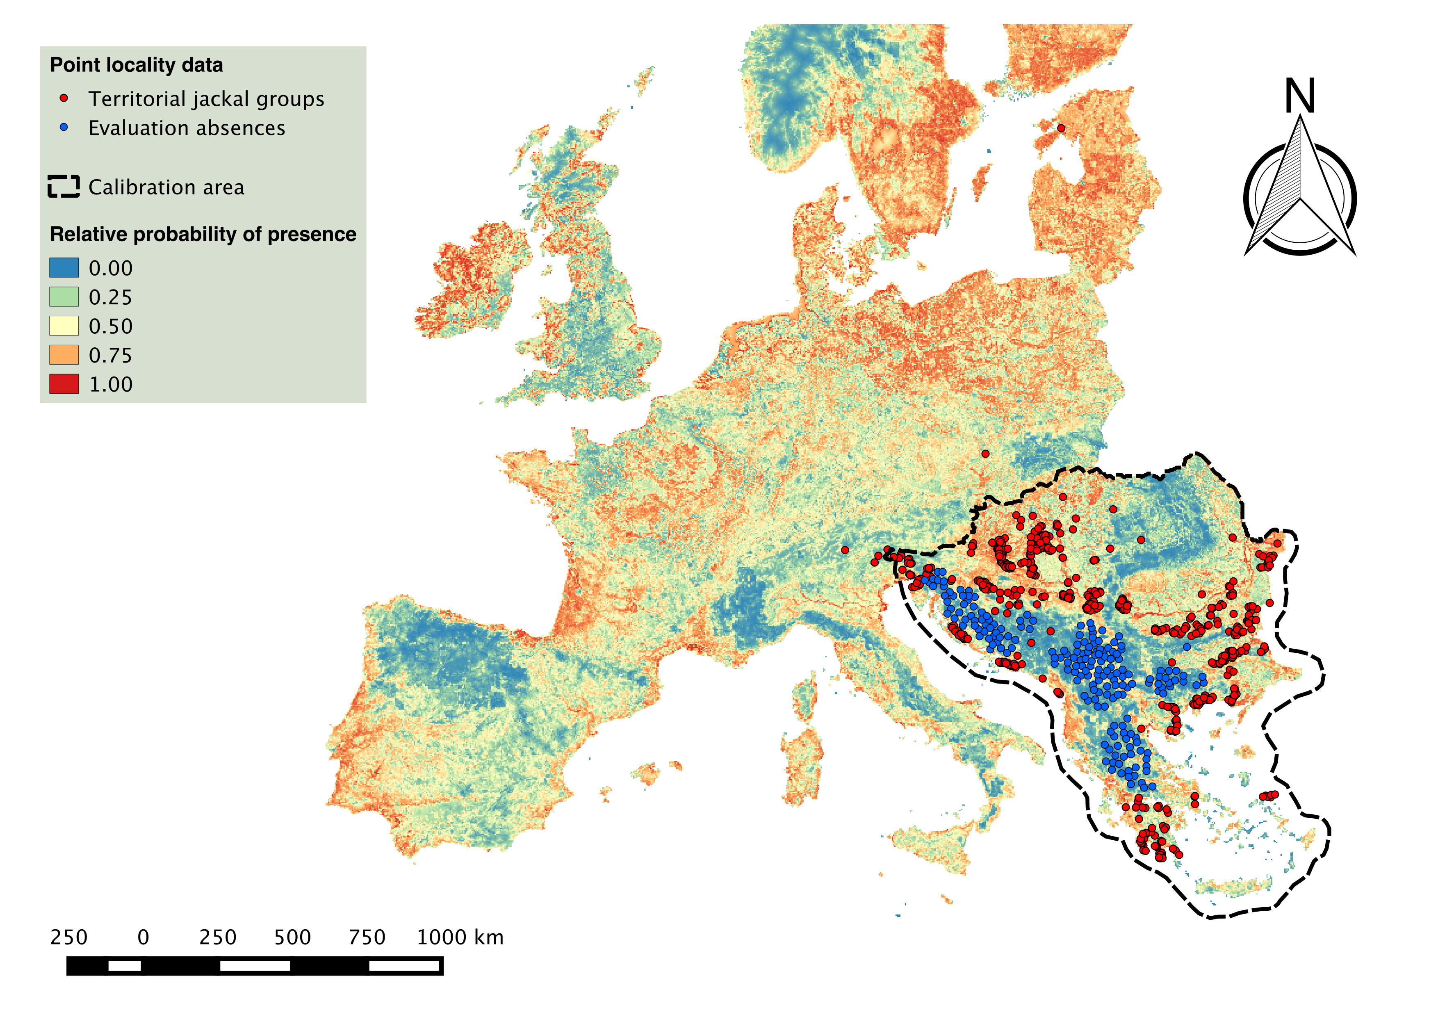
Figure 1. Ensemble model predictions of golden jackal’s relative probability of presence in Europe. Red points represent the 1,517 gathered locations of territorial jackal groups. Six of these territorial groups were recorded outside the calibration area (dashed line): 4 in Italy, 1 in Czech Republic and 1 in Estonia). Blue points display absences used for the model evaluations. Color gradients picture the golden jackal’s relative probability of presence as predicted by the ensemble model.

REFERENCES

(1) Arnold, J., A. Humer, M. Heltai, D. Murariu, N. Spassov, and K. Hackländer. 2012. Current status and distribution of golden jackals Canis aureus in Europe. Mammal Review 42 (1): 1-11.
(2) Szabó, L., M. Heltai, E. Szűcs, J. Lanszki, and R. Lehoczki. 2009. Expansion range of the golden jackal in Hungary between 1997 and 2006. Mammalia 73: 307-311.
(3) Giannatos, G. 2004. Conservation Action Plan for the Golden Jackal (Canis Aureus L. 1758) in Greece. WWF Greece, Athens, Greece.
(4) Kryštufek, B, D. Murariu, and C. Kurtonur. 1997. Present distribution of the Golden Jackal Canis aureus in the Balkans and adjacent regions. Mammal Review 27: 109–114.
(5) Lanszki, J., M. Heltai, and L. Szabó. 2006. Feeding habits and trophic niche overlap between sympatric golden jackal (Canis aureus) and red fox (Vulpes vulpes) in the Pannonian ecoregion (Hungary). Can. J. Zool 84: 1647-1656.
(6) Elith, J., M. Kearney, and S. Phillips. 2010. The art of modelling range-shifting species. Methods in Ecology and Evolution 1: 330-342.
(7) Kaczensky, P., G. Chapron, M. von Arx, D. Huber, H. Andrén, and J. Linnell. 2012. Status, management and distribution of large carnivores – bear, lynx, wolf and wolverine – in Europe, part 2. LCIE report.
(8) Giannatos, G., Y. Marinos, P. Maragou, and G. Catsadorakis. 2005. The status of the golden jackal (Canis aureus L.) in Greece. Belg. J. Zool. 135 (2): 145-149.
(9) Šálek, M., J. Červinka, O. C. Banea, M. Krofel, D. Ćirović, I. Selanec, A. Penezić, S. Grill, and J. Riegert. 2013. Population densities and habitat use of the golden jackal (Canis aureus) in farmlands across the Balkan Peninsula. Eur. J. Wildl. Res. 60 (2): 193-200.

